Investigating the adhesion of immune cells
We will study human monocytes, macrophages and dendritic cells combining three techniques. These are the high-throughput label free optical biosensor (Corning EPIC), computer-controlled micropipette (CellSorter) and the total internal reflection based TIRF microscope. All three techniques can readily monitor cell adhesion on an optically accessible planar surface. Biochemical specificity of the computer-controlled micropipette and EPIC is ensured by coating the surface with appropriate proteins. The task of EPIC is to monitor the kinetics of cell adhesion with high temporal resolution. Using TIRF microscopy we follow the localization of intracellular proteins relevant in cell adhesion. For this parallel cell cultures are fixed consecutively and labeled by immunocytochemistry. Applying the computer-controlled micropipette we can determine the adhesion force of single cells with high precision in the unit of nN. We deploy the three techniques also after RNA silencing of integrin subunits and blocking integrin receptor function with antibodies. On the basis of our experimental results we are going to construct a new biophysical model describing the kinetics of the integrin dependent adhesion of leukocytes.

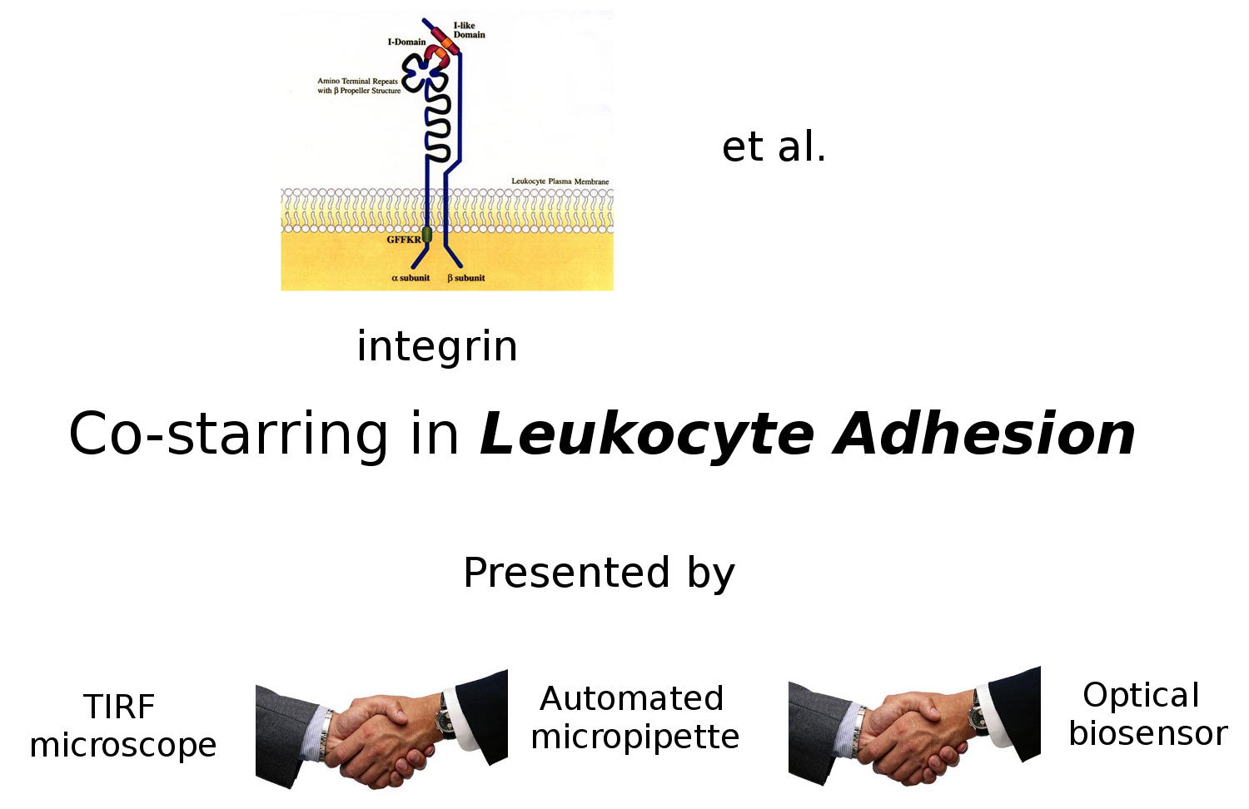
Grafikus absztrakt

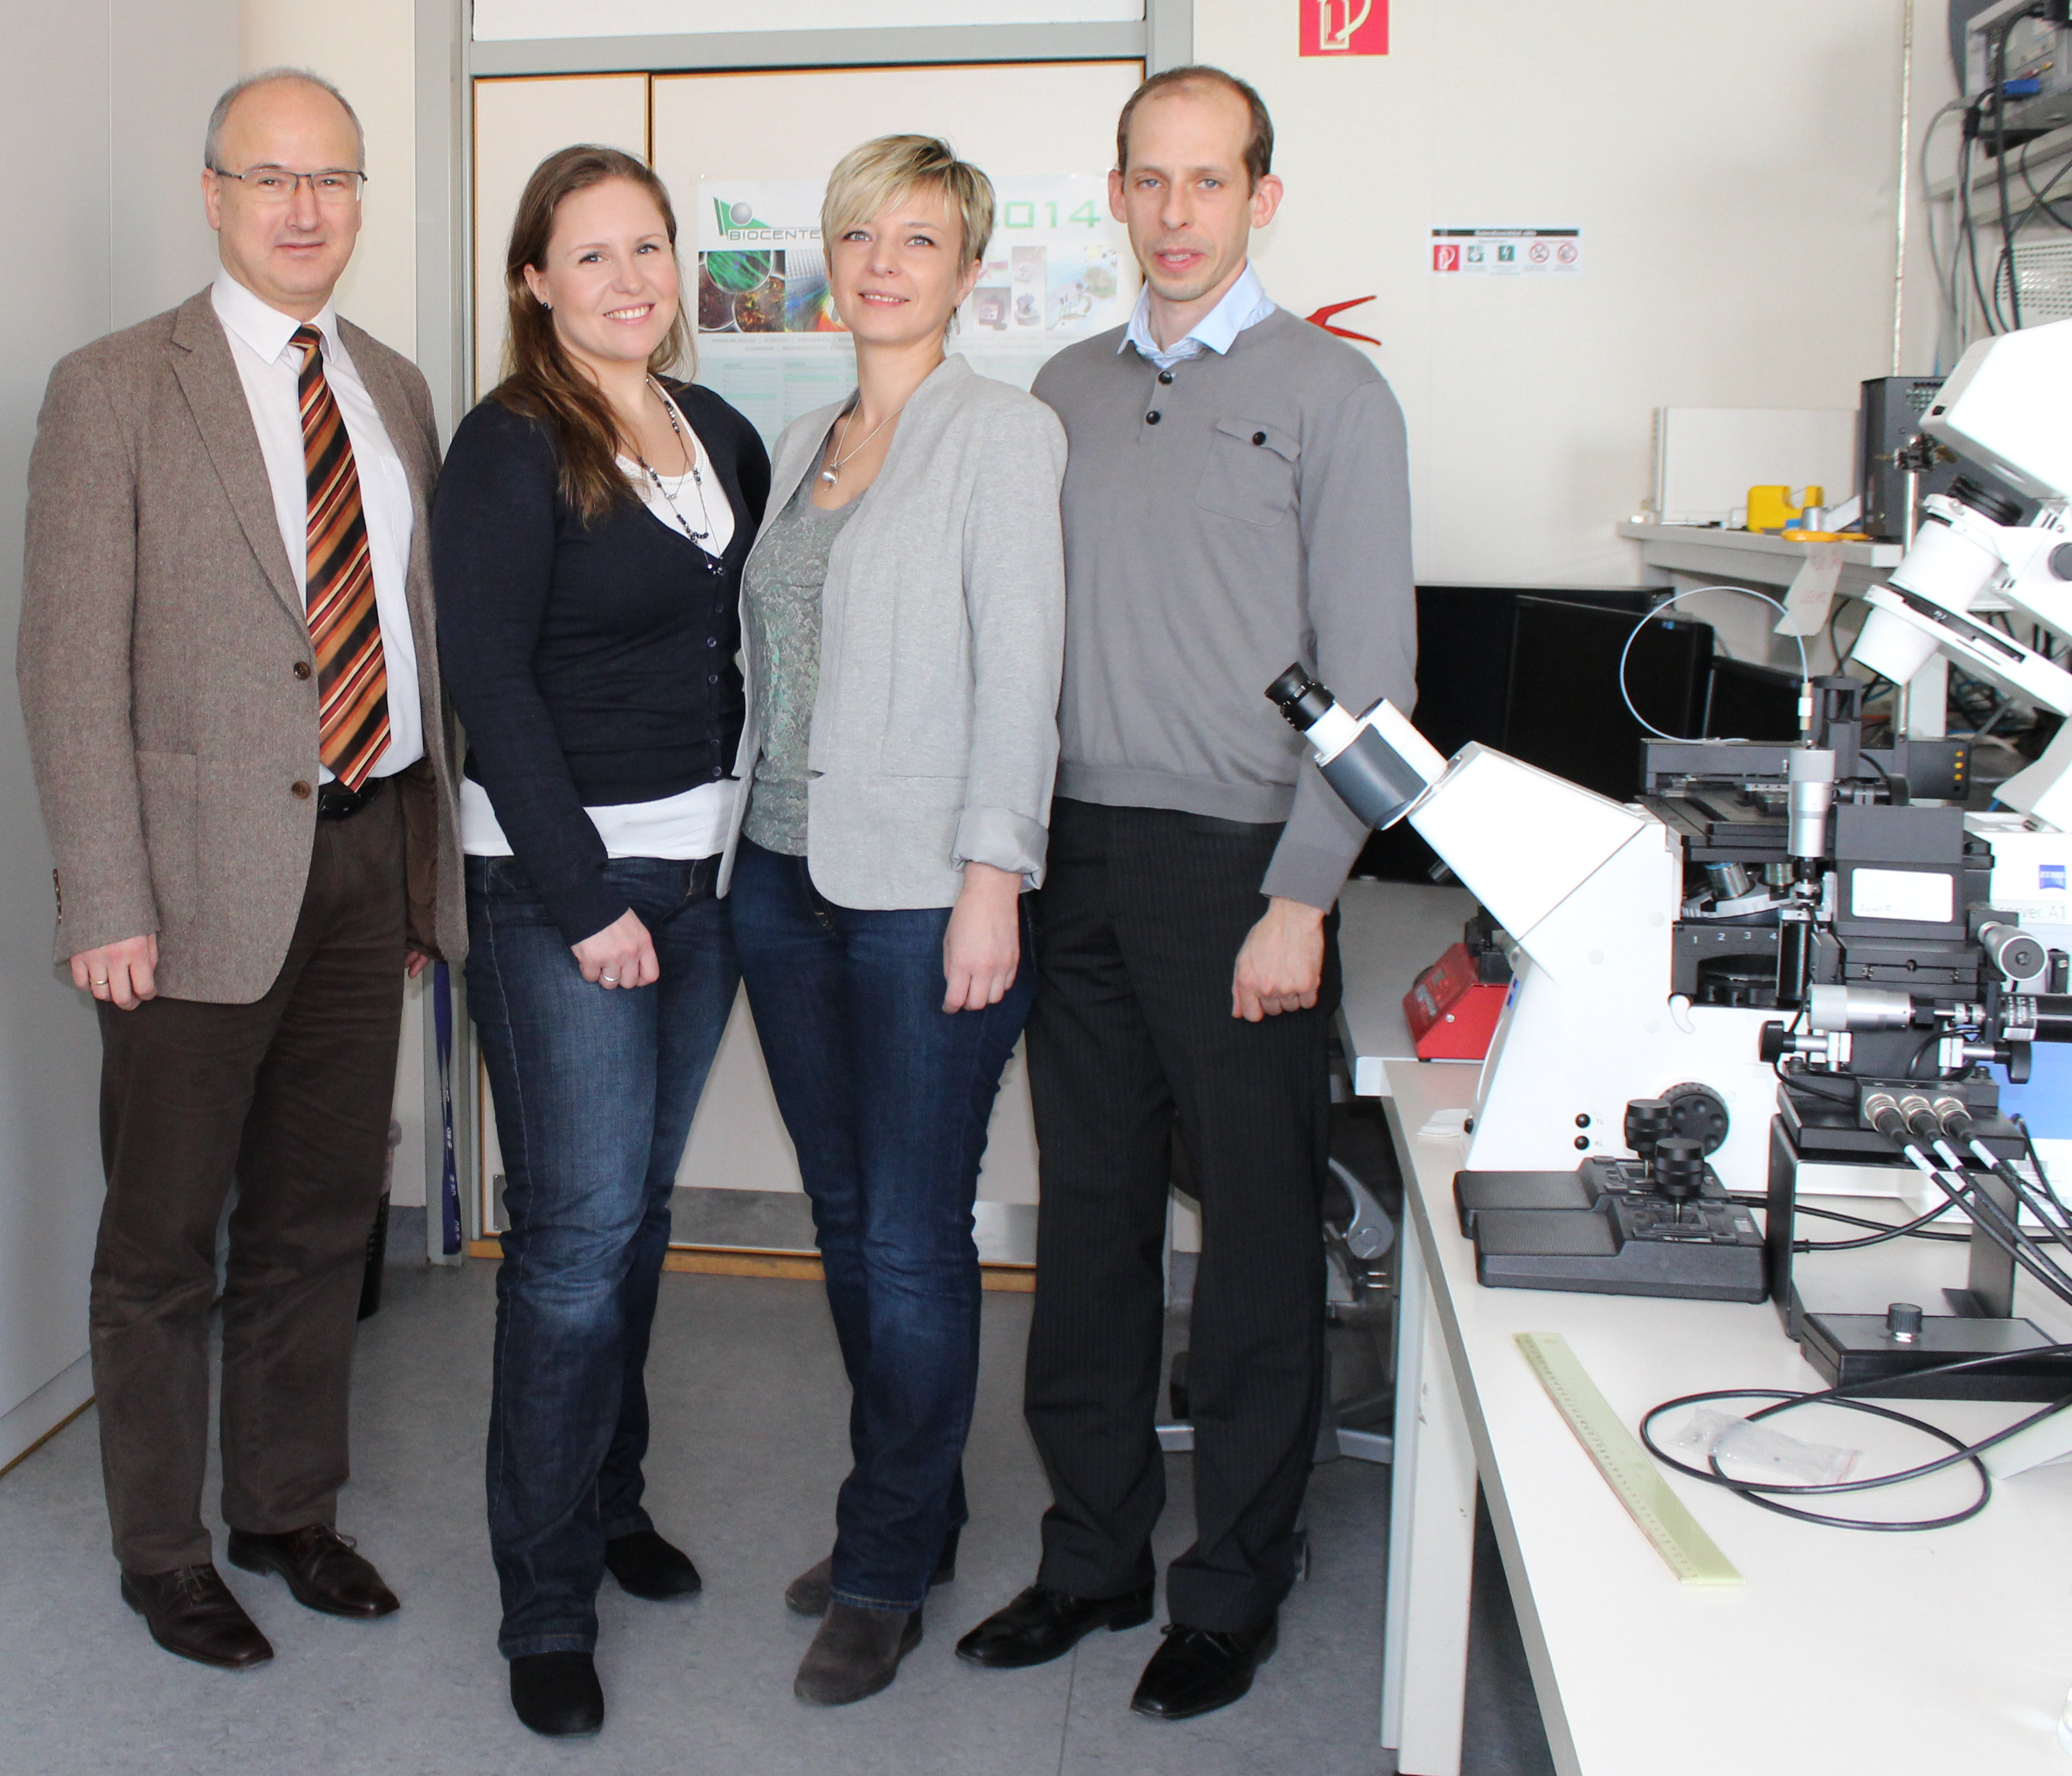
Miklós Kellermayer, Noémi Sándor, Inna Székács, Bálint Szabó

