Systems of Creation: the Emergence of Life from Non-living Matter

Stephen Mann
Centre for Protolife Research and Centre for Organized Matter Chemistry, School of Chemistry, University of Bristol, Bristol BS8 1TS, UK

The advent of life from prebiotic origins remains a deep and possibly inexplicable scientific mystery. Nevertheless, the logic of living cells offers potential insights into an unknown world of autonomous minimal life forms (protocells). This talk highlights the key life criteria required for the development of protobiological systems, and discusses how ideas about origins could lead to novel advances in the design and construction of synthetic protocells. In particular, I will review some recent experiments undertaken in my laboratory that provide steps towards synthetic representations of primitive cellularity using bioinspired chemistry principles and techniques. I will discuss four new protocell models [1-4], and use these experimental systems to discuss pathways towards chemical cognition and collective behaviour in compartmentalized chemical micro-ensembles, and to address new ideas related to prebiotic organization and the origin of life [5-8].

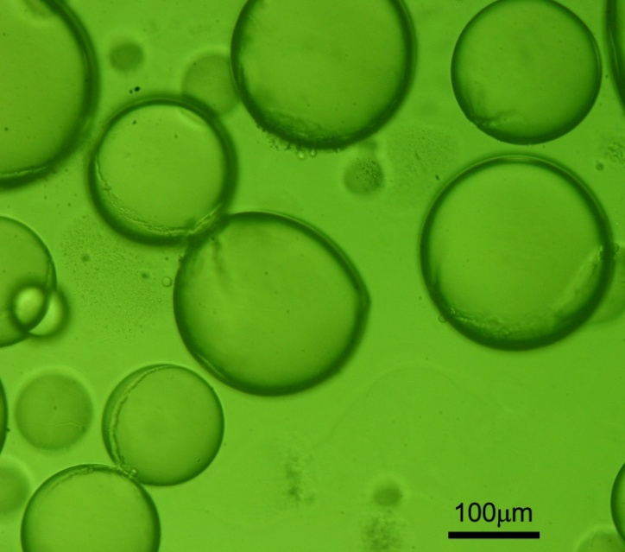
References:
[1]. Li M et al., Membrane-gated permeability in self-activated inorganic protocells. Nature Chem., 5, 529-536 (2013).
[2]. Huang X, et al., Interfacial assembly of protein-polymer nano-conjugates into stimulus-responsive biomimetic protocells. Nature Commun. 4, 2239 (2013) DOI: 10.1038/ncomms 3239, 1-9 (2013).
[3]. Koga, S., et al., Peptide–nucleotide microdroplets as a step towards a membrane-free protocell model. Nature Chem. 3, 720-724 (2011).
[4] Tang T-Y D, et al., Fatty acid membrane assembly on coacervate micro-droplets as a step towards a hybrid protocell model. Nature Chem. 6, 527- 533 (2014).
[5] Mann S, The Origins of Life: Old Problems, New Chemistries. Angew. Chemie. Int. Ed. 52, 155-162 (2013).
[6] Mann S, Systems of Creation: the Emergence of Life from Non-living Matter. Acc. Chem. Res. 45, 2131-2141 (2012).
[7] Dzieciol A J and Mann S, Designs for Life: Protocell Models in the Laboratory, Chem. Soc. Rev. 41, 79-85 (2012).
[8] Li M, Huang X, Tang T-Y D and Mann S. Synthetic Cellularity based on Non-lipid Micro-compartments and Protocell Models. Curr. Opin. Chem. Biology 22, 1-11 (2014).

