Podicin - interdependece of pathogenicity, dimerization and molecular structure

Steroid-resistant nephrotic syndrome (SRNS) is one of the most common causes of chronic renal failure in childhood. Mutations of the NPHS2 gene, encoding the slit diaphragm protein podocin, are responsible for 12-18% of the SRNS cases. As a member of the stomatin family, podocin is known to form oligodimers. We formerly showed that the NPHS2 R229Q variant is only pathogenic when trans-associated to specific 3’ missense mutations. These associations lead to abnormal dimerization and mislocalisation of podocin. A 3’ frameshift mutation (F344Lfs*4) has been recently found enriched in patients with R229Q, underlying the pathogenicity of their association. The aim of the present project is to compare the effect of this frameshift mutation to other, both pathogenic and non-pathogenic 3’ frameshift mutations. The effect of different truncating mutations and their associations will be studied on a transiently expressed podocyte cell line. A homology model of the podocin was built based on the structure of Pyrococcus horikoshii stomatin, and is applied in the computational studies aimed at understanding the molecular details of the structure and dimerization propensity of different variants. The subset of podocin variants proposed to be responsible for dimerization was expressed and purified and is studied by chromatographic methods as well as CD and NMR spectroscopy, to support our hypotheses. Protein expression systems and different constructs of the entire C-terminal domain of podocin are tested extensively to produce sufficient amount of protein to attempt its crystallization and structure determination. We expect to understand the relationship between the dimerization, the subcellular mislocalization of podocin and the clinical phenotype.

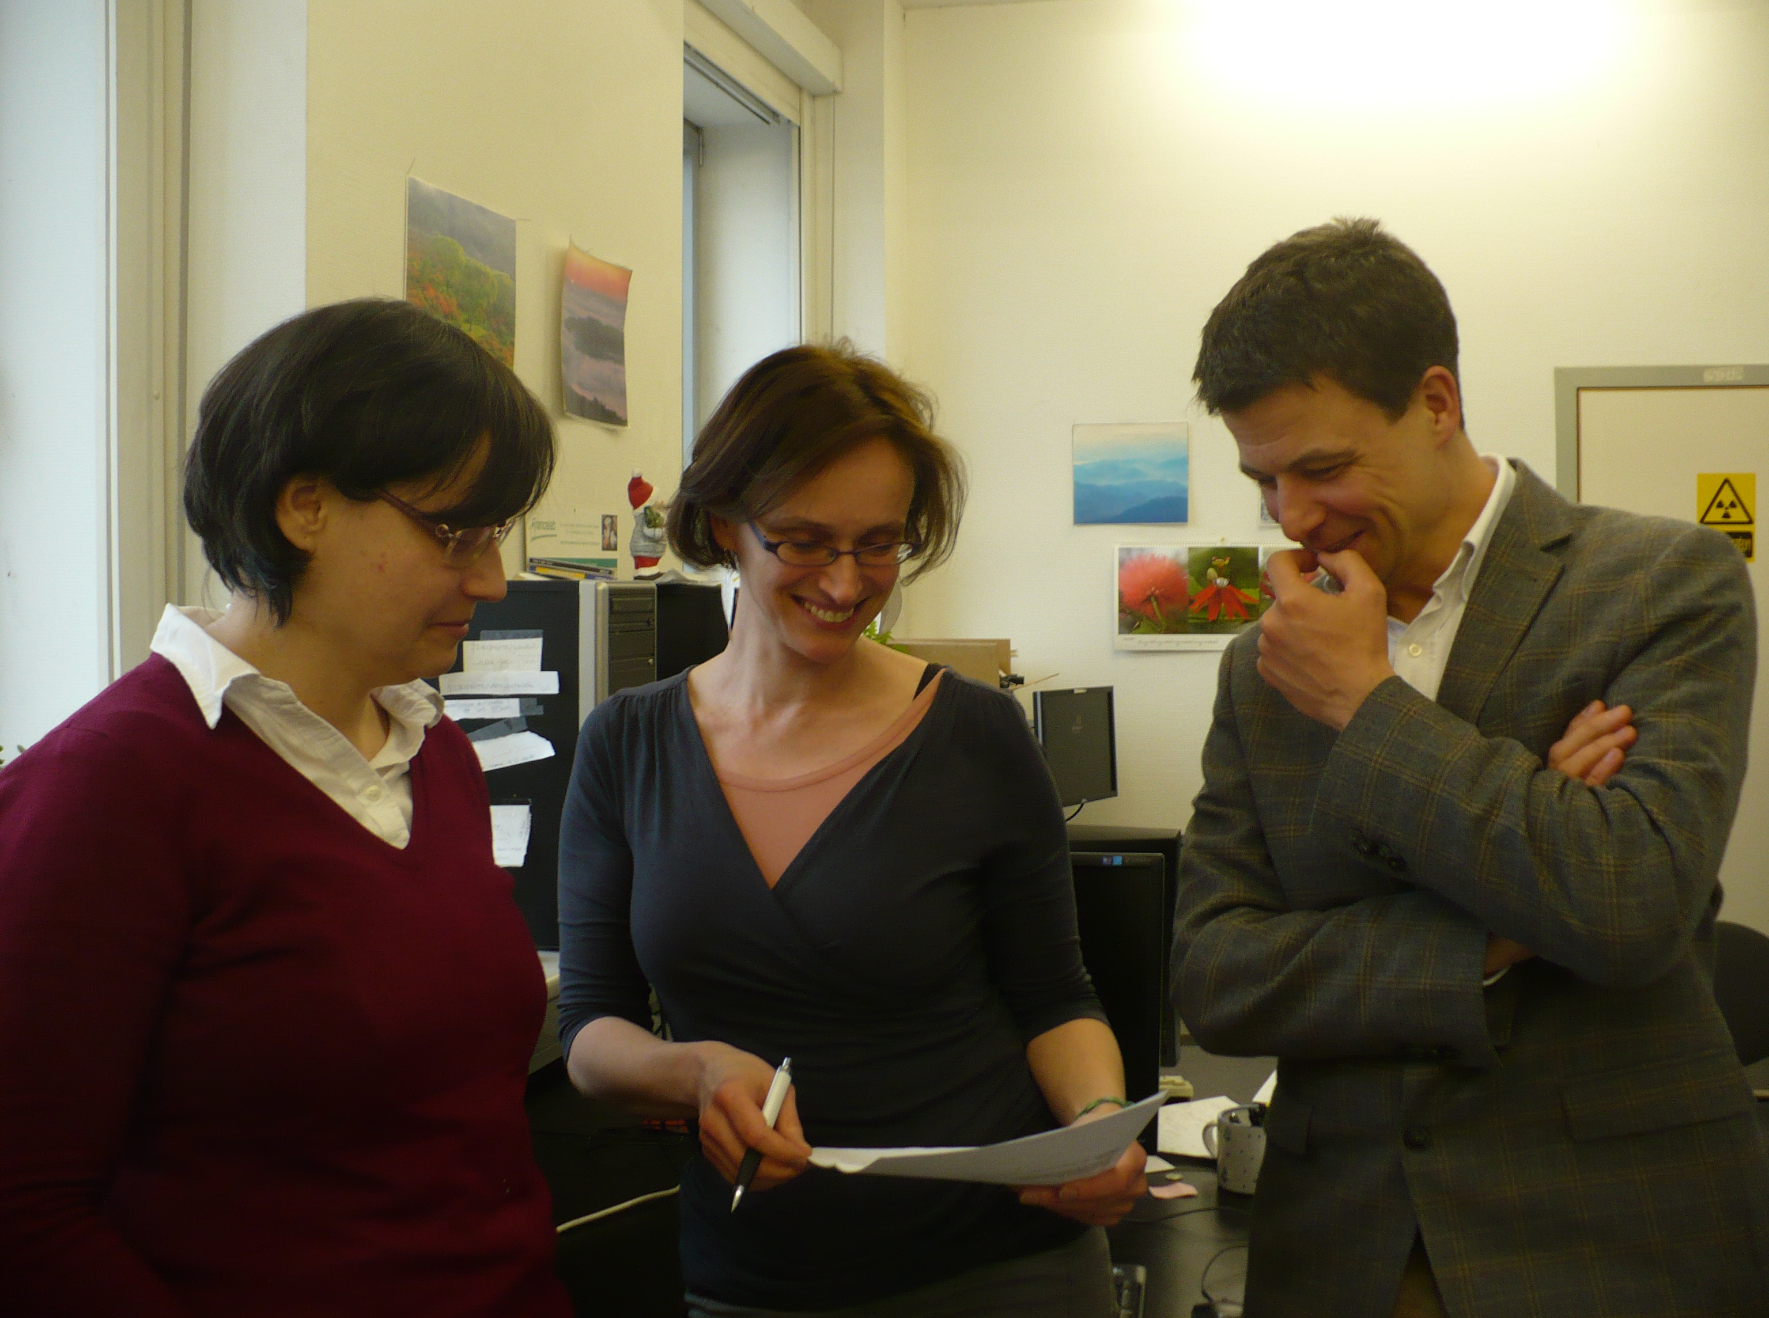
Veronika Harmat – Dóra Karancsiné Menyhárd – Kálmán Tory

