Structural insight into the mechanism of complement activation through a hybrid approach of crystallography, electron microscopy and small angle X-ray scattering
Gregers R Andersen, Department of Molecular Biology and Genetics, Aarhus University, Denmark
The complement system is an essential arm of the innate immune defense mediating resolution of infections, clearance of immune complexes, removal of apoptotic/necrotic cells, and stimulation of adaptive immunity. Complement may be activated when pattern recognition molecules associate with e.g. pathogens, immune complexes or altered self tissue representing danger. This cause activation of serine proteases associated with the pattern recognition molecules. The resulting proteolytic complexes are giant ( ~450 kDa) flexible surface bound enzymes with an unusual and highly non-globular architecture. Such macromolecular complexes are unlikely to crystallize. In order to provide structural information concerning the molecular mechanism of complement activation we have employed a hybrid approach involving partial crystal structures of smaller fragments in combination with X-ray solution scattering and electron microscopy. In accordance with our recent biochemical studies (1) the resulting structural models show that activation of complement through the so-called lectin pathway is an intermolecular reaction (2). This challenges the current dogma concerning complement activation suggesting it to be an intramolecular reaction relying on conformational changes induced upon binding of the pattern recognition molecule to the complement activating surface.
Molecular model showing several complexes between pattern recognition molecules and serine proteases assembled on a bacterial glycan layer. Such complexes have maximum dimensions of more than 300 Å.
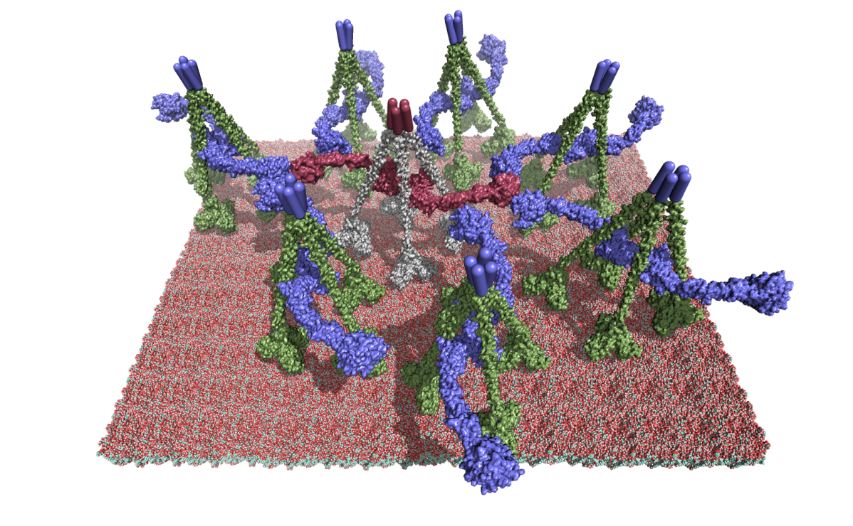
1. Degn, S. E., T. R. Kjaer, R. T. Kidmose, L. Jensen, A. G. Hansen, M. Tekin, J. C. Jensenius, G. R. Andersen, and S. Thiel. 2014. Complement activation by ligand-driven juxtaposition of discrete pattern recognition complexes. Proc Natl Acad Sci U S A 111: 13445-13450.
2. Kjaer, T. R., L. T. Le, J. S. Pedersen, B. Sander, M. M. Golas, J. C. Jensenius, G. R. Andersen, and S. Thiel. 2015. Structural Insights into the Initiating Complex of the Lectin Pathway of Complement Activation. Structure. published online 6-1-2015.

