**Studying *in vivo* effect of cell-penetrating inhibitor peptide conjugates on protein-protein interaction**

1. Conjugates containing the cell-penetrating peptides R8-RHDF and penetratin-RHDF were prepared, both with and without fluorescent markers. The peptides were prepared using solid-phase peptide synthesis and conjugated in solution phase via thioether bonds. Synthesis of conjugates containing the identified cell-penetrating peptides is in progress.

2. We treated HEK293 cells with R8-RHDF and penetratin-RHDF conjugates, and examined the time and concentration dependence of their cell-penetration by fluorescence microscopy (Fig.1). We found that after 4-6h incubation at 10-20 µM the conjugates were concentrated in the cells, and they had no toxic effects.

3. After incubating cells with these cell-penetrating conjugates, we followed the activation of the ERK2 signal pathway using anti-phospho-ERK2 Western-blot. After serum starvation and treatment with R8-RHDF or penetratin-RHDF peptides we stimulated cells by EGF (Fig.2). We observed that peptides can decrease the activation of the ERK2 pathway.

4. Protein Fragment Complementation Assays to determine the inhibition effect of the conjugates on protein interactions are in progress.

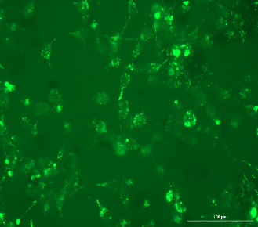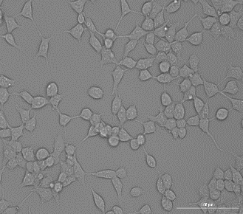

**Fig.1 : R8-Rhdf-CF peptide enters into HEKT293 cells (20 µM, 5h)**



**Fig.2 :Effect of R8-Rhdf-CF peptide (20 µM, 5h) on the Erk2-pathway.**

**Anti-P-Erk2 Western blot normalized to Erk2 level,**

**EGF stimulation (100 ng/ml).**